Database Backup-VolunteerLog

*The VolunteerLog Database is backed up every day at 8:00 PM if the computer is on.

- Start the database server(mysql) if not already running
- Find a backup file (vlogbackup##.sql), this is the data and everything to recreate the database quickly
- Open the XAMPP Control Panel C:\XAMPP\xampp-control.exe and click “Shell” OR use the command line(cmd.exe) and change directory
- Create the database if it doesn't exist: MYSQLADMIN -u root -ppassword VolunteerLog
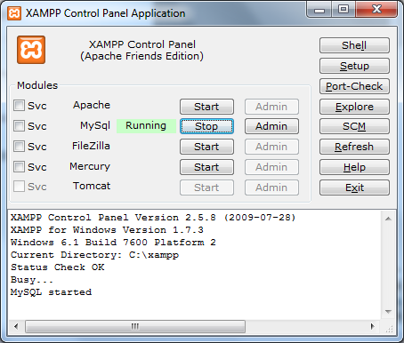
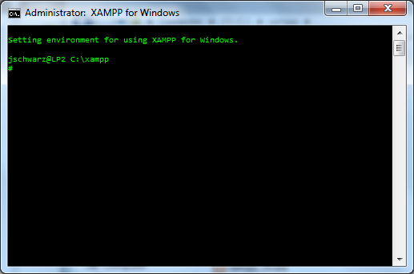
- Type MYSQL -u root -ppassword < ^{[FULL PATH TO FILE USING /]} VolunteerLog

